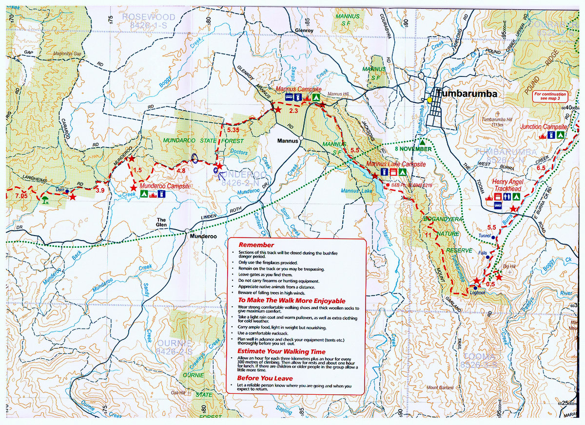Simple-Compass-Rose-2[1]



Mannus Lake Check Point 34 km

Support Crew Access. Drop Bag Table.

**Safety Bag Check**



50 km Turnaround 32.00 km, back

through Mannus LakeCheck Point

Mt Garland Check Point

25.80 km/ 38.20km

Junction Campsite Check Point, turnaround 6.5km. Back through Henry Angel Check Point .

**No support crew access.**

Henry Angel 50 km Start,

north to Junction Campsite Check Point. 13km return/ Mt Garland 12.80 km.

Support Crew Access

Drop Bag Table.

51km Finish

**50 km Map**

**Hume & Hovell Ultra**

Start at Henry Angel, go north, turnaround at Junction Campsite CP, back through Henry Angel CP, on out through Mt Garland CP, through Mannus **Lake** CP to the turnaround. Come back through Mannus Lake CP, on to Mt Garland CP, then return to Henry Angel finish.

Check Points will have, water, Gatorade, jellybeans, snakes, watermelon, bananas, oranges, chips, coke, vegemite sandwiches, fruit cake, gels.



Copied from Hume & Hovell Walking Track Pack Map 4 Department of Lands

